TetrisBlast

User Manual

**.DUEL**

**TABLE OF CONTENTS**

INTRODUCTION…………………………………………………..….3

SYSTEM REQUIREMENTS………………………………………….3

INSTALL INSTRUCTIONS…………………………………………..4

HOW TO PLAY……………………………………………………….4

TROUBLESHOOTING………………………………………….….…5

TECHNICAL SUPPORT………………………………………………6

**INTRODUCTION**

TetrisBlast, a name of a game that so familiar to most of the people. TetrisBlast is a puzzle-type game. Its history started in year 1984. There are so many version came out later on. But all the playing rules are more or less the same. There are seven type of blocks which are shown below. Players have to use their brain to arrange those blocks so that blocks are filled up a line and dissolved.

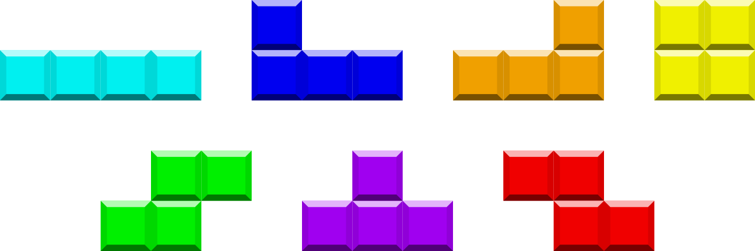

**SYSTEM REQUIREMENTS**

* Pentium 133MHz
* 16MB RAM
* 75MB Hard Disk Space
* 2MB Video RAM
* 4x CD-ROM Drive
* Direct3D Graphics Accelerator Supported
* 16-bit High Color, 640x480 Resolution
* DirectX-compatible Sound Card
* Gamepad, Joystick, Keyboard

**INSTALL INSTRUCTIONS**

To get TetrisBlast, players can search it on Google Play. Then, players could just download it from the Google Play. There is no price for the game so it is free. After the download, the game is automatically installed by itself. After that, players could click on the app icon and starts the game. TetrisBlast is an offline game so there is no need to get online to play it.

**HOW TO PLAY**

A block which generated randomly by the system will falls from the top to the bottom. Players could choose to make every block vertical or horizontal.

Primary goal of players is to arrange the blocks so that they filled up a line and the line would dissolved by itself. Players could move the block either to the left or to the right. Players could also make the block either in horizontal or vertical. The block would drops faster if players want it. If players failed to fill up a line, blocks would keep on dropping on the previous blocks. When the block is reached the top of playing field, the game is over and players have to start over again. So, players have to try their best to dissolve the line as fast as possible and as many as possible. The score is based on how many lines the players could dissolved.

**TECHNICAL SUPPORT**

Technical support E-mail: [virgo_wnwh6717@hotmail.com](mailto:virgo_wnwh6717@hotmail.com)

Please try to adhere the report form rules. Thank you!

Fill the subject field with “TetrisBlast”.

Letter body should contain text information about your:

* Windows and DirectX version
* Core processor
* RAM memory amount
* Hard drive free space amount
* Sound card and its driver version
* Detailed problem description

***COPYING PROHIBITED***

*This software product and the manual are copyrighted and all rights are reserved by .DUEL, and are protected by the copyright laws that pertain to computer software. You may not copy the software. You may not modify, adapt, translate, create derivate works, decompile, disassemble, or otherwise reverse engineer or device source code from all or any portion of the software or anything incorporated therein or permit or encourage any third party to do so.*

**CREDITS**

**.DUEL**

Script:

William

Project manager:

Mike

Game designer:

Chong

The Programmer:

Mike

Chong

Sound Producer:

Ziv

Fatt

Testers:

William

Ziv

Fatt